**Pre-Lab 9:**

**BJT Amplifier Design**

Name: Wan-Yu Liao

ECEN 325 Section 514

TA: Mandela

Date: November 1, 2019

**Calculation**



**Simulation**

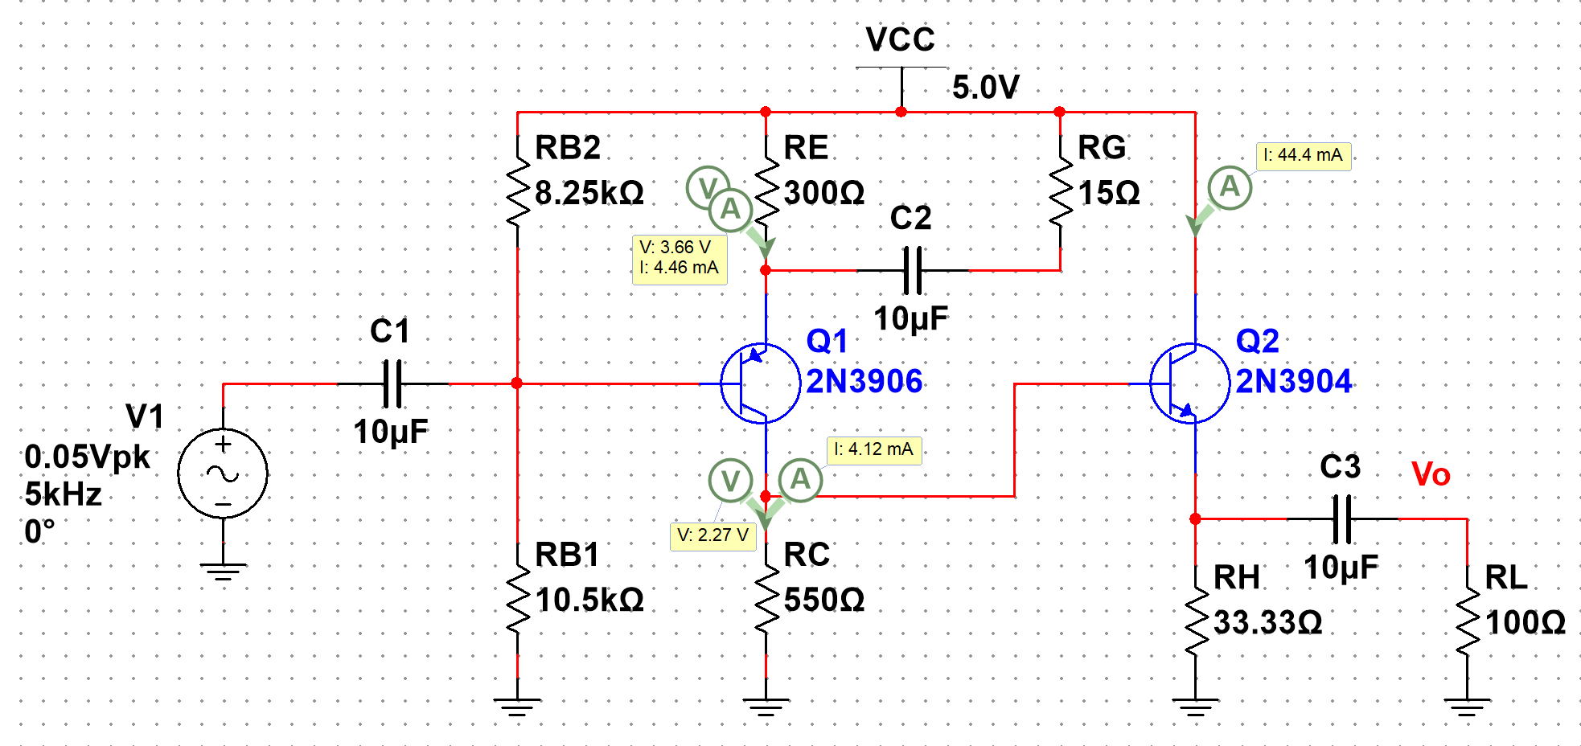

**Figure 1:** DC solutions

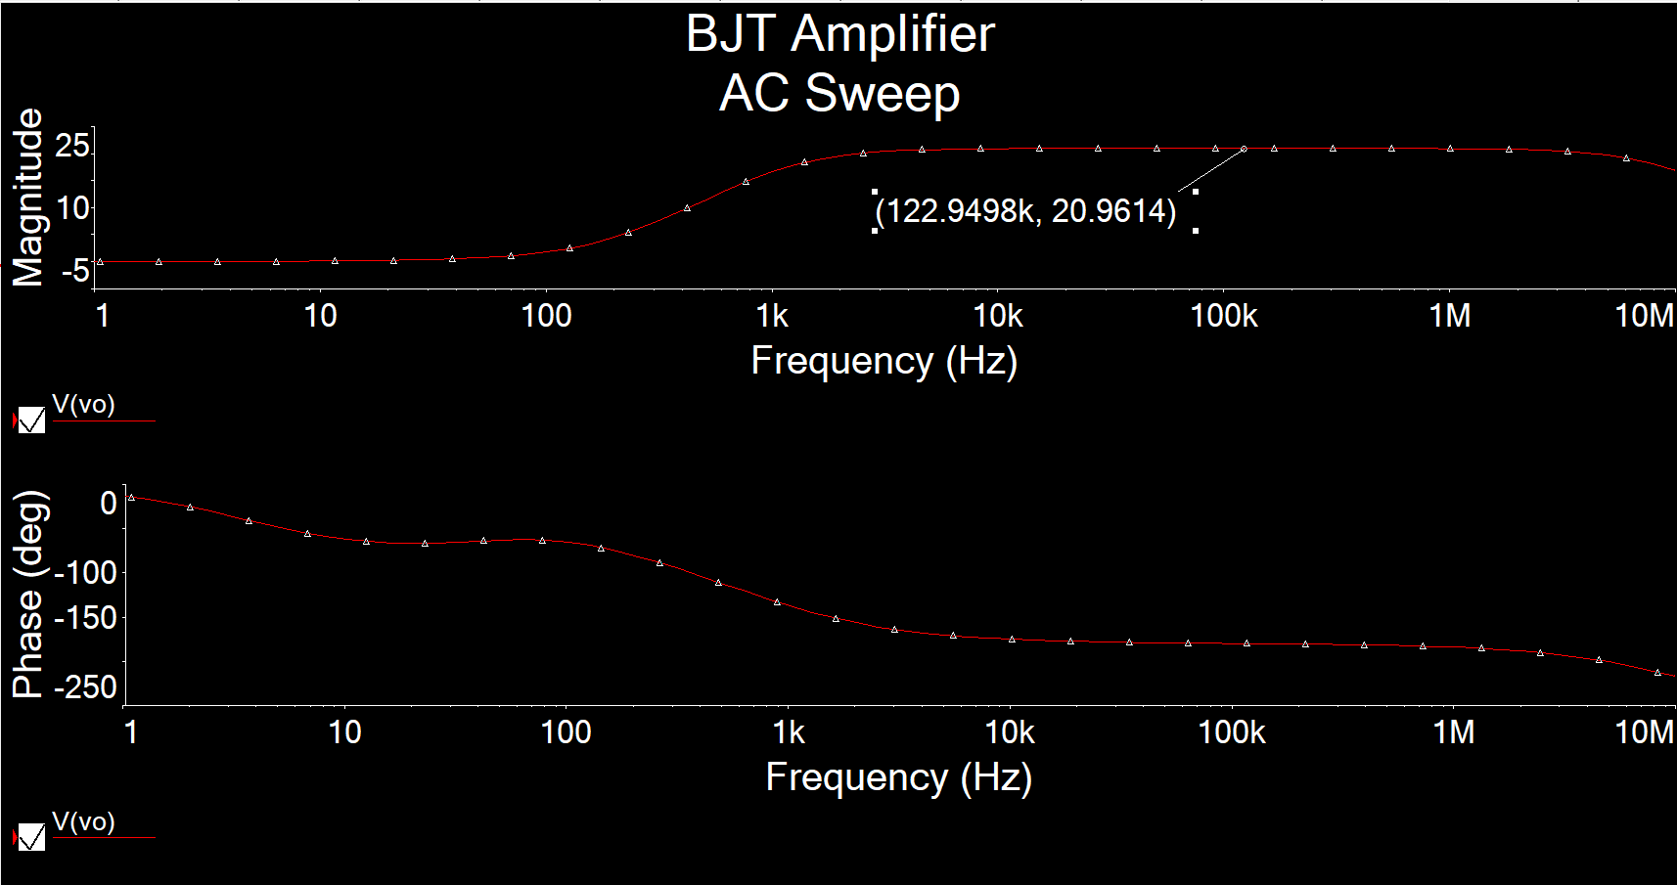

**Figure 2-1:** AC Simulation of Av

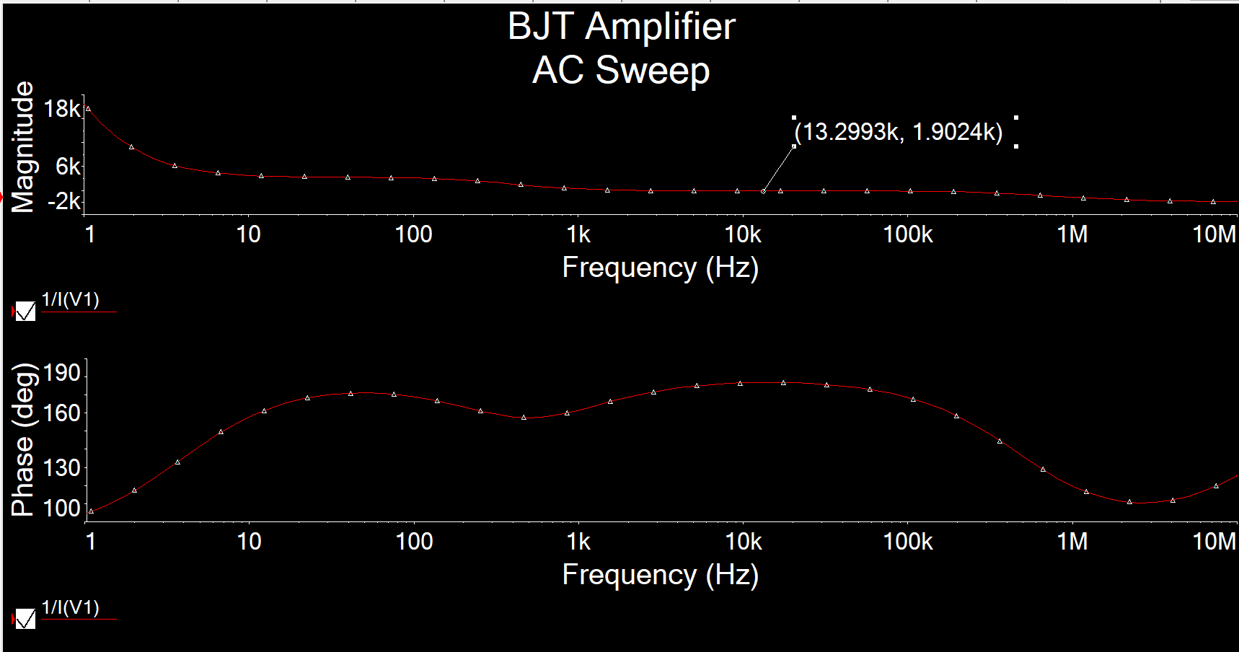

**Figure 2-2:** AC Simulation of Ri

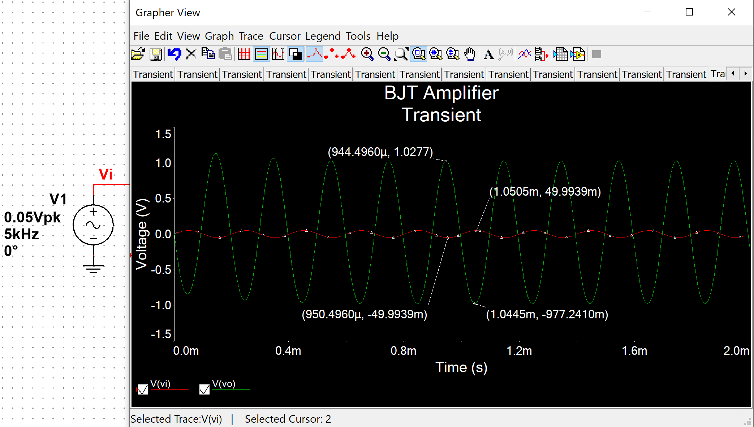

**Figure 3:** Time-domain waveform

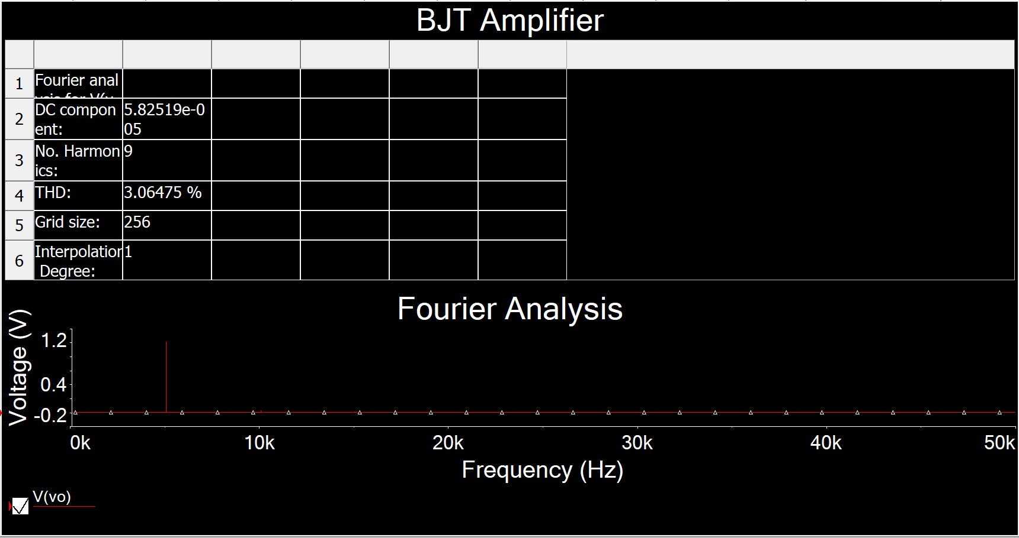

**Figure 4:** THD

THD = 3.06% which is less than 5%